**Revision Sheet**

|  |  |  |
| --- | --- | --- |
| **Release No.** | **Date** | **Revision Description** |
| Rev. 0 | 1/10/2014 | User’s Manual Created |
|  |  |  |
|  |  |  |
|  |  |  |
|  |  |  |
|  |  |  |

Table of Contents

1.0 General Information 1

1.1 System Overview 1

1.2 Acronyms and Abbreviations 1

1.3 System Summary 2

1.4 User Access Privileges 2

2.0 Getting Started 3

2.1 Setting up WAMP 3

2.2 Creating and Setting up the Database 9

3.0 Using the Mana Staff Management System 11

3.1 Staff Details 12

3.2 Leave Management 16

3.3 Timetable 20

3.4 Administrative Tasks 24

4.0 Reports 25

4.1 Staff Report 25

4.2 Leave Report 26

4.3 Timetable Reports 26

5.0 Error Messages 27

6.0 About us 28

## General Information

### System Overview

Mana staff management system is an application that utilizes an intuitive user interface that makes imputing and editing records fast and efficient. This program provides a graphical user interface that allows a user to input all information and store it electronically to exterminate the need for using paper records.

This program uses a client/server based model. The client is what the user uses to add staff’s records as well as edit them. The client program will communicate with MySQL server that saves all the information for each staff member. The information saved in the database is about staff members who receive services from Mana staff management System. It includes some of their personal information (i.e. name, Contact number, NIC etc.), services provided to them by Mana, Manage their Staff Details, leave’s information and Time table details.

### Acronyms and Abbreviations

Mana – Name of the system. Used to symbolize an impersonal supernatural power which can be transmitted or inherited.

MySQL –This is a database management system.

PHP – is a widely-used open source general-purpose scripting language used for web development.

WAMP – Windows, APACHE, Microsoft and PHP.

SQL – Structured query language.

### 1.3 System Summary

#### 1.3.1 System Configuration

A computer running either Windows operating system or Linux operating system is required. On that computer the client will access the central database where all the information is stored. For this purpose WAMP should be installed to run the application.

**System Overview Diagram**

Mana Staff Management System

### 1.4 User Access Privileges

Users of the system are given different access rights for security purposes. The Administrator of the system can control these permission under the manage users module. Where he can either promote a user to view all sections of the system or restrict them from viewing certain areas of the system.

## 2.0 Getting Started

### 2.1 Setting up WAMP

Step 1:

Open your web browser

Go to this website: <http://www.wampserver.com/en/>

Under the downloads menu click download WAMP server (32 bits & PHP 5.5) or WAMP server (64 bits & PHP 5.5)

Select one according to your computer’s preference

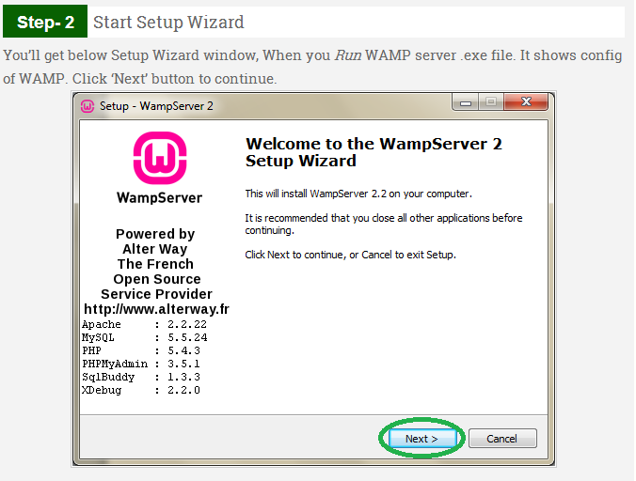

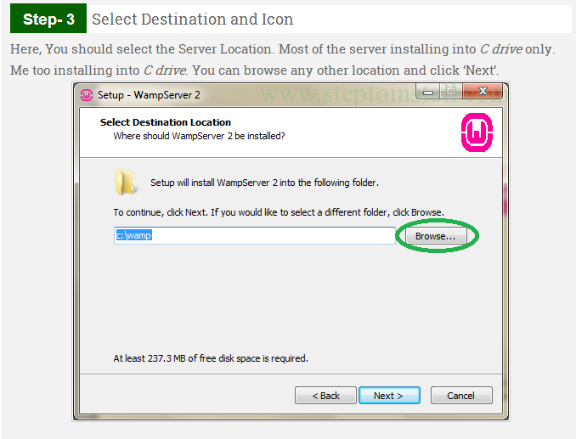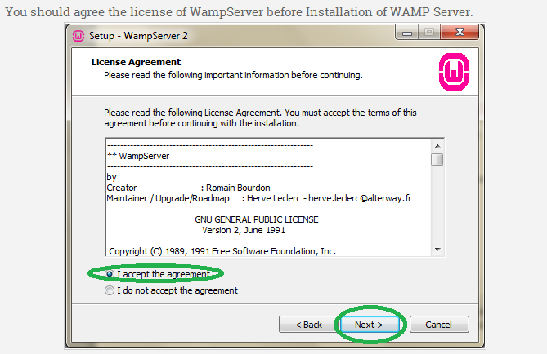

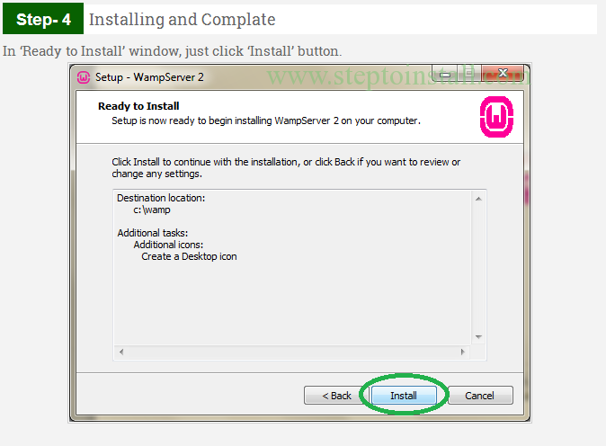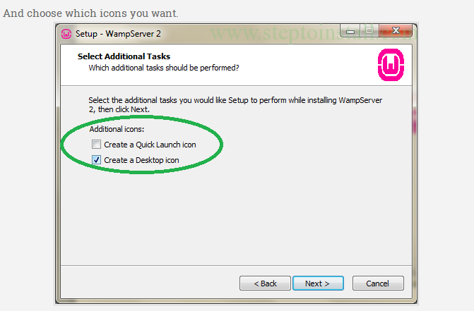

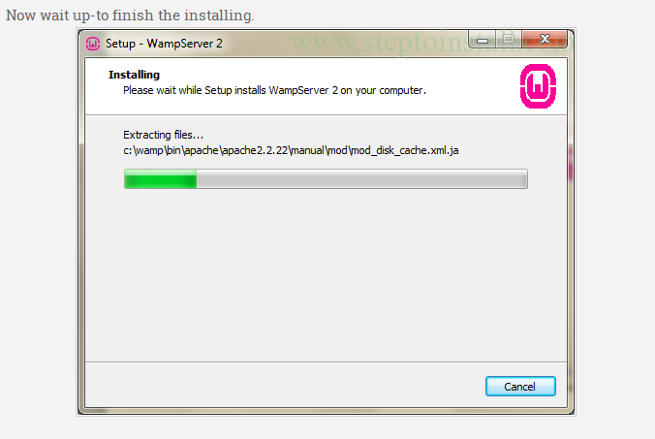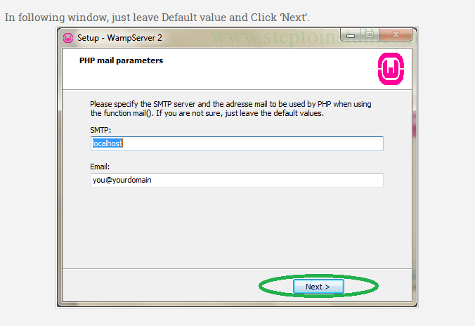

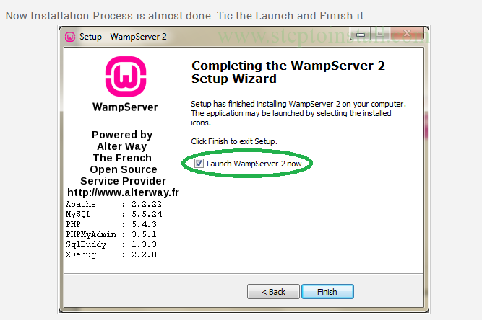

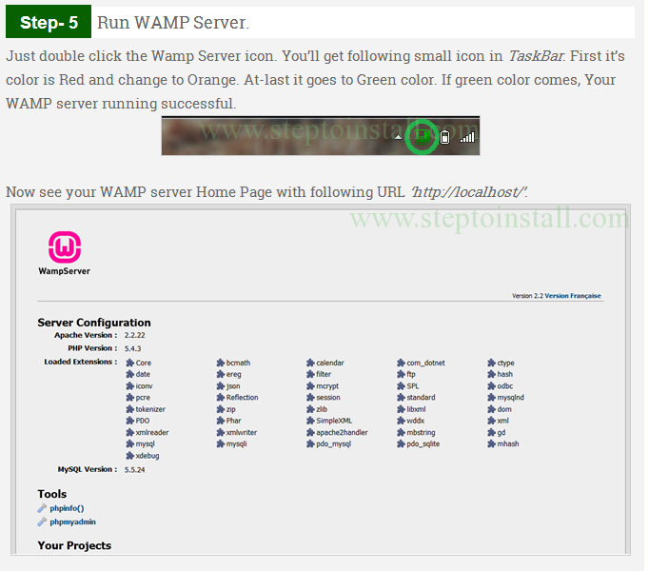

### 2.2 Creating and Setting up the Database

To create the database, the sql needed to make it will be provided for you. Simply copy the SQL code on to phpMyAdmin found in WAMP and then click go.

Firstly, head to phpMyAdmin

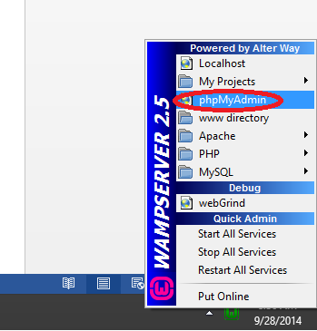

You will then be directed to a similar page. Click on SQL as shown below:

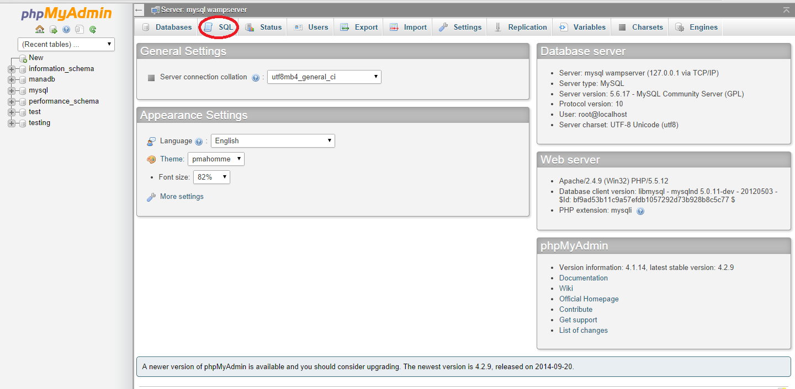

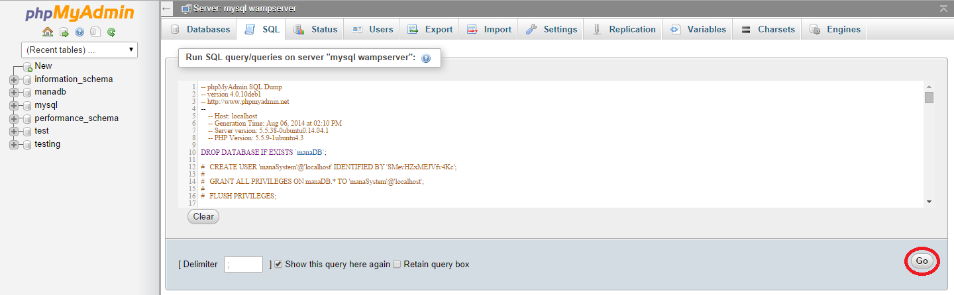Use the import facility in phpMyAdmin to create the database.

You will then be given a success message and your database will be successfully created!

## 3.0 Using the Mana Staff Management System

Once you login you will be shown the following page (Home):

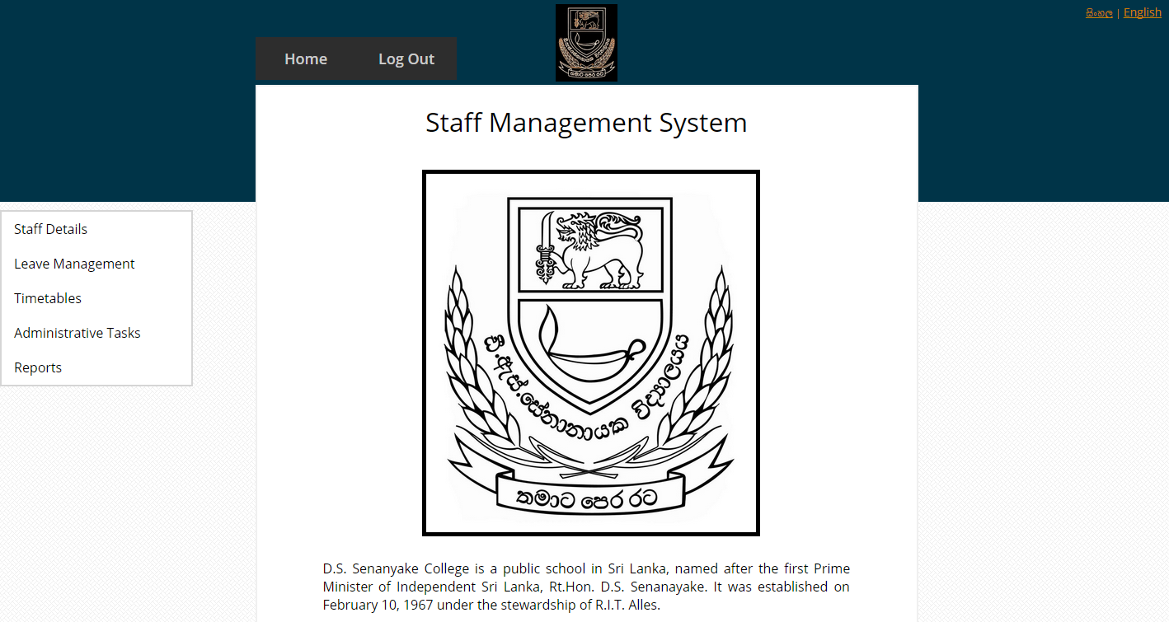

The left side menu consists of all the functions included in the system.

* Staff Details
* Leave Management
* Timetables
* Administrative Tasks
* Reports

### 3.1 Staff Details

#### 3.1.1 Staff registration

Staff registration is divided into three parts (General Information, Employment Information and Education Information). Once all the appropriate information has been filled, the staff details can be added to the database.

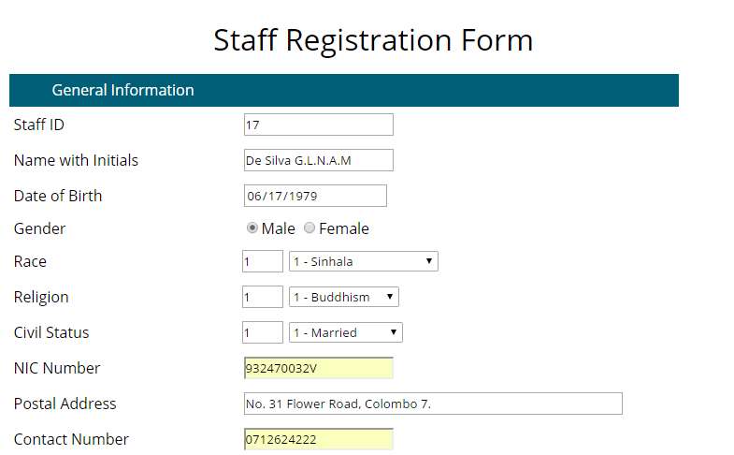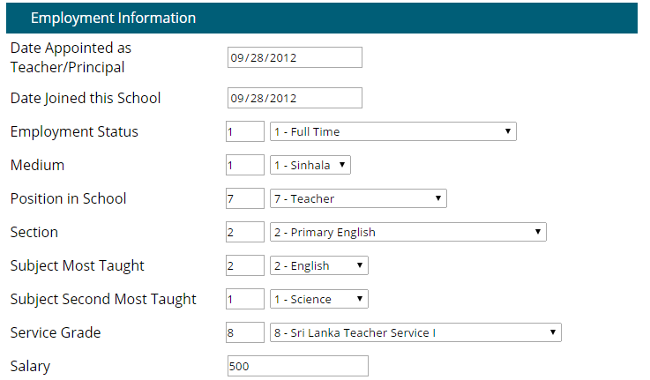This is the staff registration form:

Once all details are filled click the “Submit” button. You will then be shown a success message. As shown below:

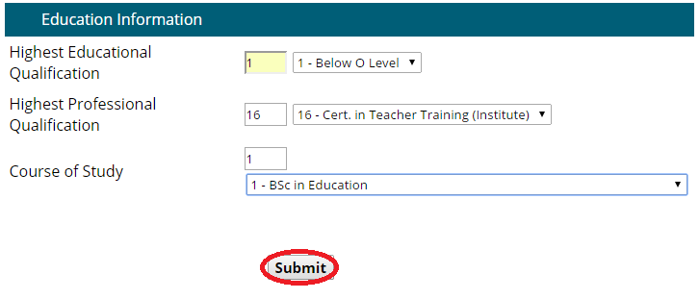

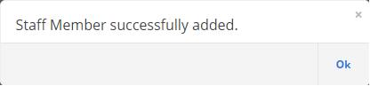

#### 3.1.2 Search and Update

If the user wants to search for a specific staff member, the system has provided a facility in which the user can choose between searching by Staff ID, Name with Initials, NIC Number or Contact Number.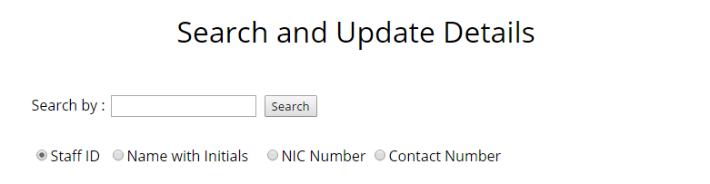

Once the user selects the desired search criteria, enters the search parameter and clicks “Search” then he/she will see a list showing the relevant details. In the list there are two buttons called Expand Details and Delete.

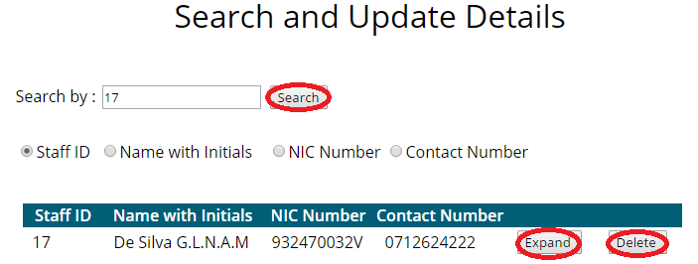

If the user desires to see all the details then he/she can click the “Expand” button to view the details.

If the user wishes to delete the staff member from the database then they can click the “Delete” button. You will then be given a confirmation message box as shown below.

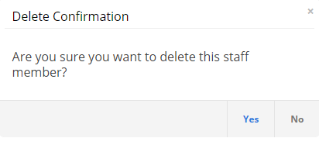

Click on “Yes” if you’re sure about deleting the staff member.

#### 3.1.3 Class Teacher Allocation

To allocate a teacher to a classroom the follow these steps:

Firstly enter the Grade and Class and then enter Staff ID meaning the teacher you want to assign to the class and click on “Update”.

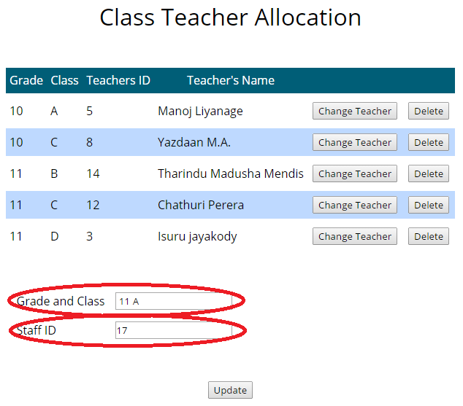

The user may also change the teacher of a specific class by clicking “Change Teacher” or they may delete a teacher from a class by clicking on “Delete”.

### 3.2 Leave Management

Under this section it allows the user to apply for leave, approve leave and check the leave status of staff members.

#### 3.2.1 Apply for Leave

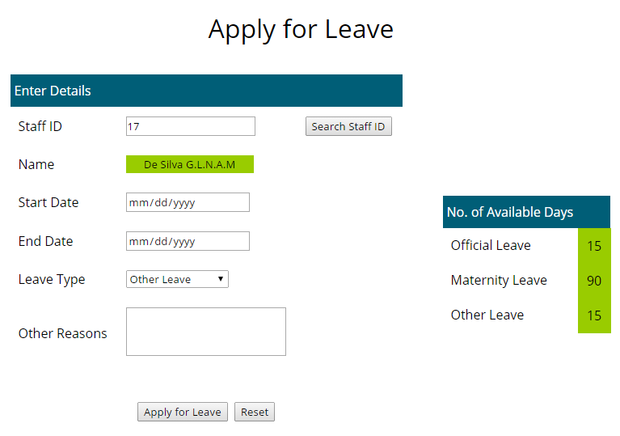This form allows users to apply for leave. The user can enter the Staff ID and the name of the staff member will automatically be retrieved and be displayed in the Name text field if the Staff member exists in the system.

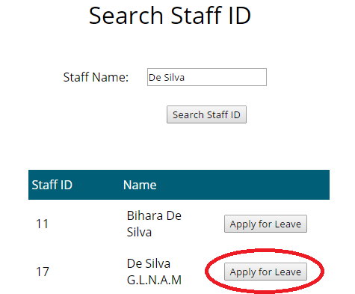If the user does not know the staff id then he can click the “Search Staff ID” button to search for the staff member by name. After searching click the “Apply for Leave” button to redirect to the main page.

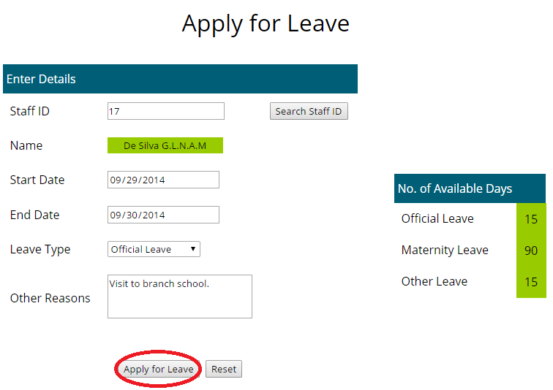The user can then enter the rest of the details and click on “Apply for Leave” button as shown below:

After clicking apply for leave a confirmation message will be displayed

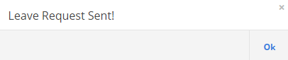

#### 3.2.2. Approve Leave

In this form the user may approve or reject leave requests. Click on “Expand Details” button to get the detailed list view and then click on either “Approve” or “Reject”.

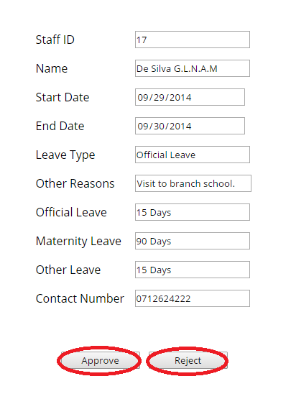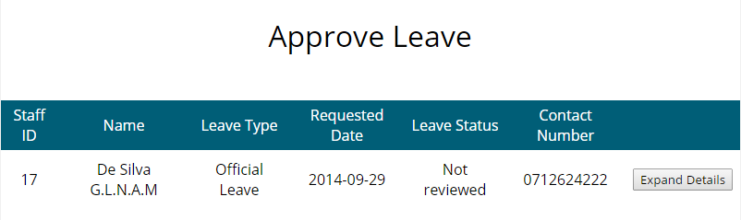

#### 3.2.3 Check Leave Status

The user may also check his/her leave status meaning whether it is approved or not by clicking on “Check Leave Status” under “Leave Management” in the side menu.

Simple enter the Staff ID and your most recent leave request will be shown with its status of approval as shown below:

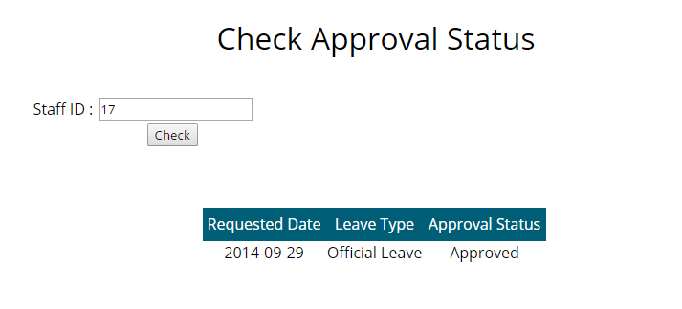

### 3.3 Timetable

Under this menu the user is allowed to insert a timetable, allocate a teacher to a class, substitute a teacher and view the class timetable.

#### 3.3.1 Teacher’s Timetable

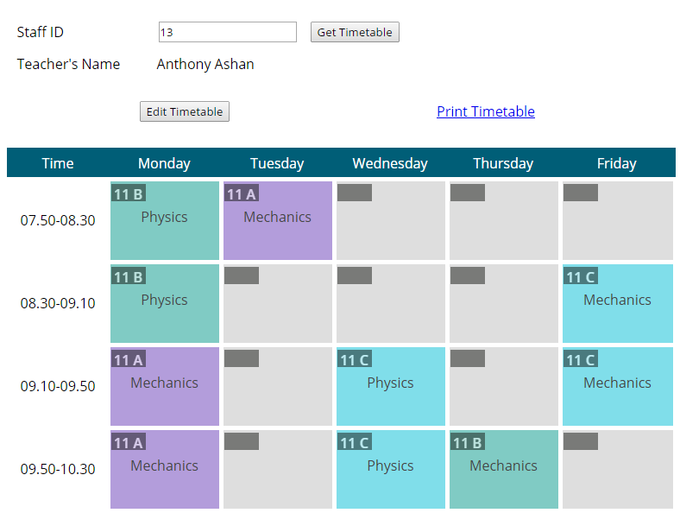Shown below is the teacher’s timetable. Here you can enter the staff id and click the “Get Timetable” (1) button to retrieve the specific teacher’s timetable. To edit the timetable click the “Edit Timetable” (2) button and then the timetable becomes editable. After completing the changes to the timetable click the “Edit Timetable” once more to save. If the user requires a printout of the teacher’s timetable then he/she can click the “Print Timetable” (3) link.

3

2

1

#### 3.3.2 Class Teacher Allocation

Previously explained under “Staff Details” section 3.1.3.

#### 3.3.3 Substitute Teacher

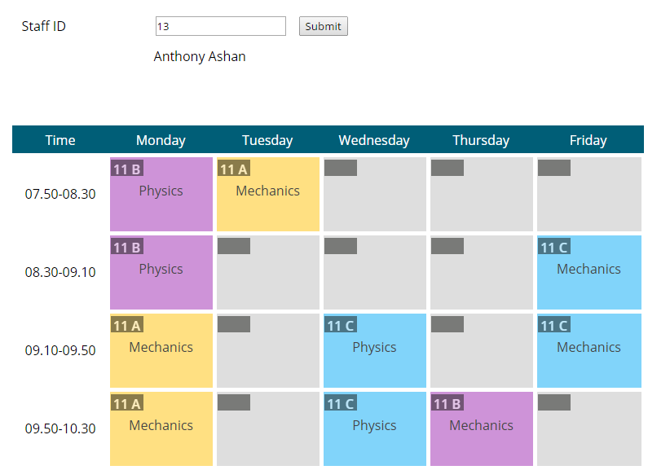In the substitute teacher form, the user has to enter the staff id of the teacher who requires substituting. Once you have entered the staff id then you click the “Submit” button to generate the teacher’s timetable. Then click on the specific period in which the teacher is not available.

A message box will appear confirming whether there are teacher’s for substitution.

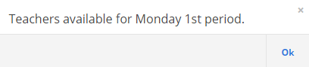

You will then be given a list of teachers who are available for substitution:

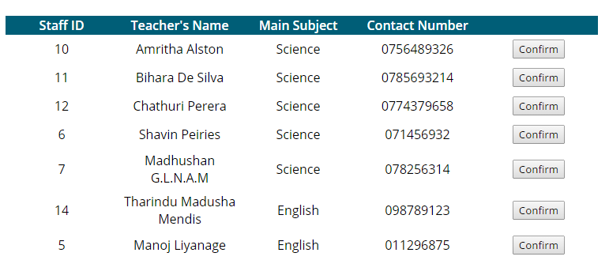

Click the “Confirm” Button and you will be then given the following prompt box:

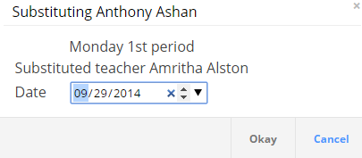

Enter the date and click the “Okay” button, confirm the message box that comes immediately after and your teacher will be successfully substituted.

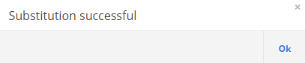

#### 3.3.4 Class Timetable

In the class timetable form, the user can view the class timetable. Simply enter the Grade and Class, click the “Get Timetable” button and the timetable will be generated as shown below.



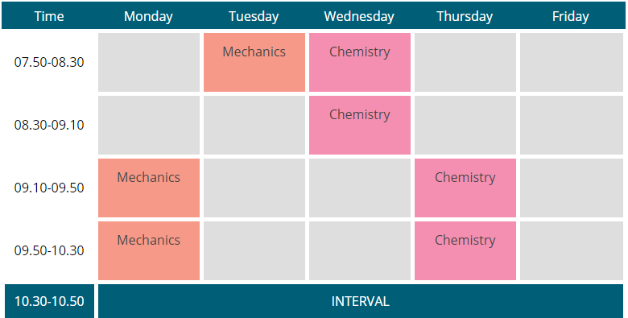

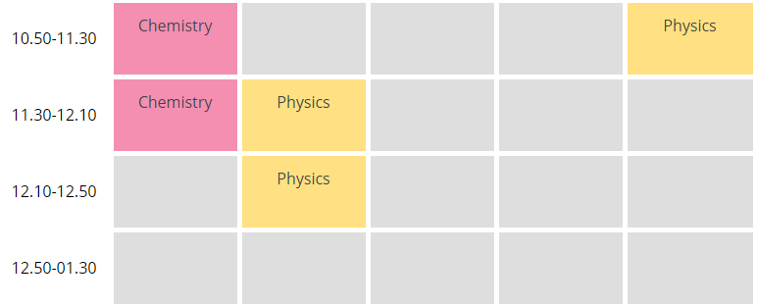

If the user requires a printout of the class timetable, click the “Print Timetable” link to produce a printout of the class timetable.

### 3.4 Administrative Tasks

Under this menu you can manage the users of the system and their permissions.

#### 3.4.1 Add a new user

To add a new user, click the manage user’s link under Administrative Tasks in the side menu.

Enter the email, password, define the access level and click “Submit”

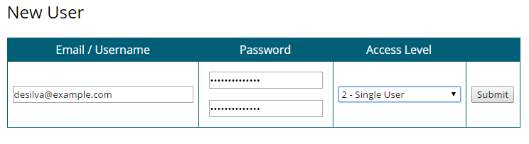

#### 3.4.2 Search for a user

You can search for a user in the manage user’s form. A list containing all the users will be displayed. Simply enter the search criteria and the matching results will be highlighted. You can also reset their password or completely delete the user.

## 4.0 Reports

### 4.1 Staff Report

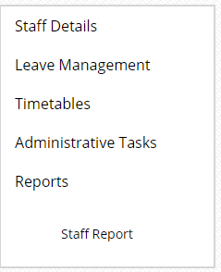

To generate a staff report click on the link shown above given in the side menu and you will be directed to a new tab with the report.

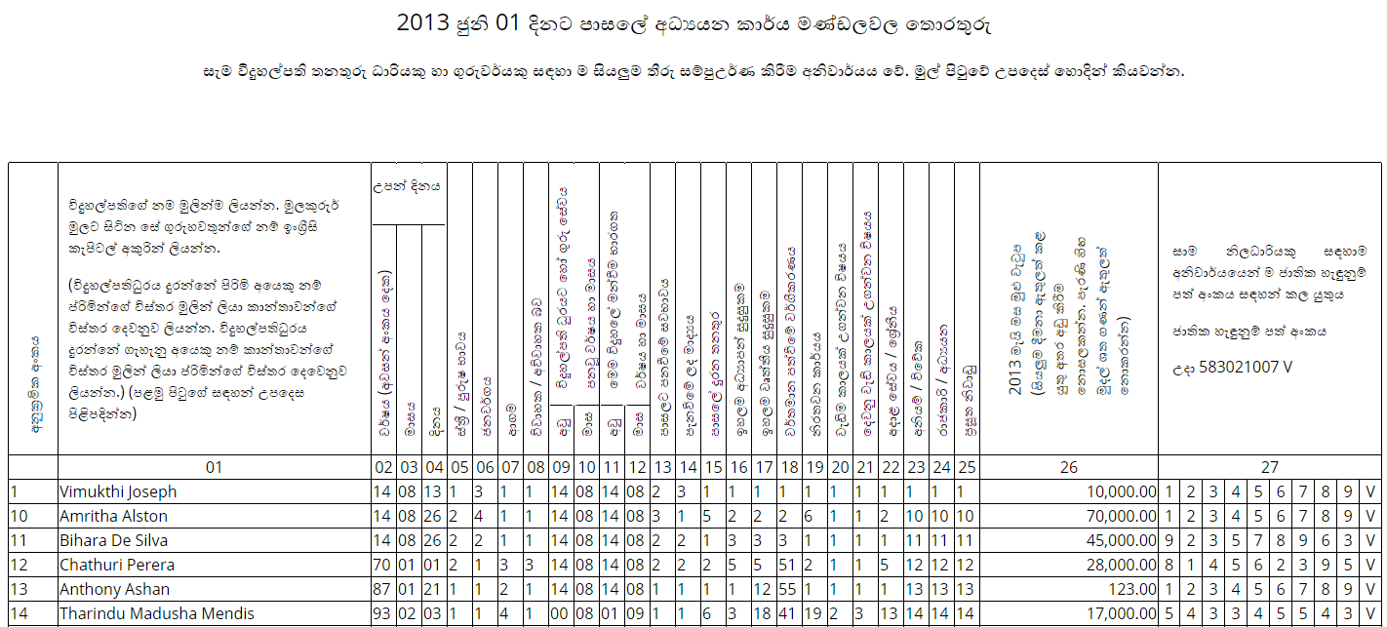

### 4.2 Leave Report

To generate a leave report of each staff member:

1. Click on generate leave report
2. Enter the staff id
3. 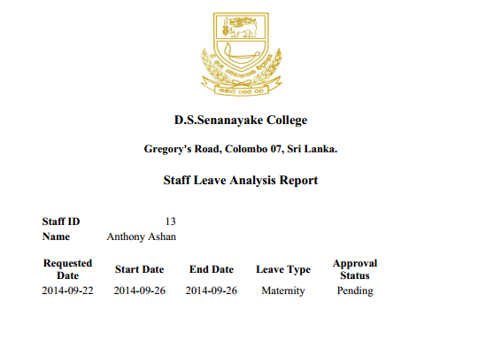Click on “Generate Report”

### 4.3 Timetable Reports

#### 4.3.1 Teacher’s Timetable Report

Please refer section 3.3.1 (Teacher’s Timetable).

#### 4.3.2 Class Room Timetable Report

Please refer section 3.3.2 (Class Timetable).

## 5.0 Error Messages

Staff member does not exist in the database of the system.

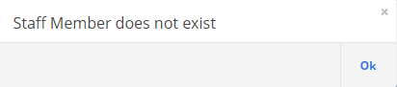

The Staff ID entered is an invalid one. You may have typed in letters or other characters instead of numbers.

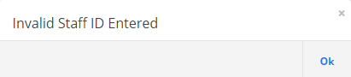

You have taken up all the available leave days for official, maternity and/or other leave

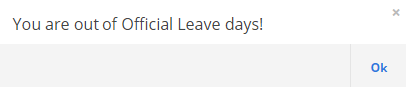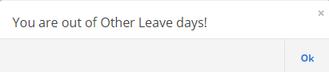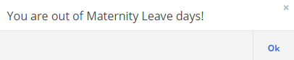

## 6.0 About us

The Mana Staff Management System was developed for D.S Senanayake College under the direct supervison of Mr. Prasanna S. Haddella of SLIIT and was done as part of the 2nd year ITP module conducted at Sri Lanka Institute of Information Technoloy (SLIIT).

List of Developers Involved:

1. M.Y. Alimudeen
2. B.T.M. Mendis
3. M.S.E. Peiries
4. M.C. Liyanage
5. V.S. Joseph
6. R.M.D.A. Rathnayake
7. J.A.I. Jayakody
8. G.L.N.A.M. De Silva